Lesson 3- Properties of Materials Date:_________________
Outcome SM3.1 : Investigate properties of materials and methods of joinery used in structures.

I can… Examine the properties of materials used in natural and human-built structures
I can… Sort materials for use in constructing structures according to one or more physical
Deeper level thinking questions. After reading the I can… statements make questions that you would like to know about the topic talked about in the statements. If there is more than one I Can… statement then you split up the total amount of questions to cover all of the I Can… statements
Gr. Three - 2 questions Gr. Four - 3 questions Gr. Five - 4 questions
Self Assessment Circle One: 4: I go beyond what is expected 3: I am Independent 2: I need some help 1: I do not understand
I learned best by: _______________________________________________________________________________
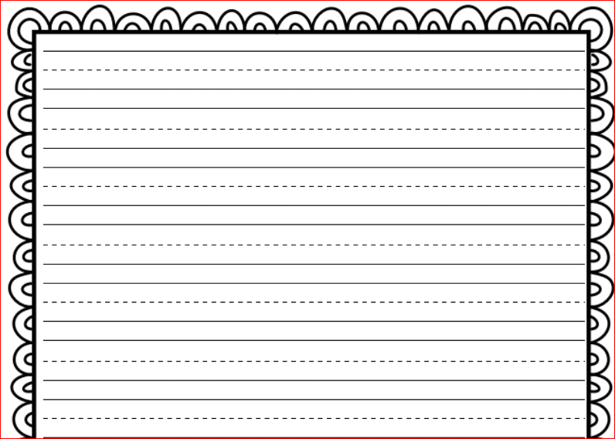
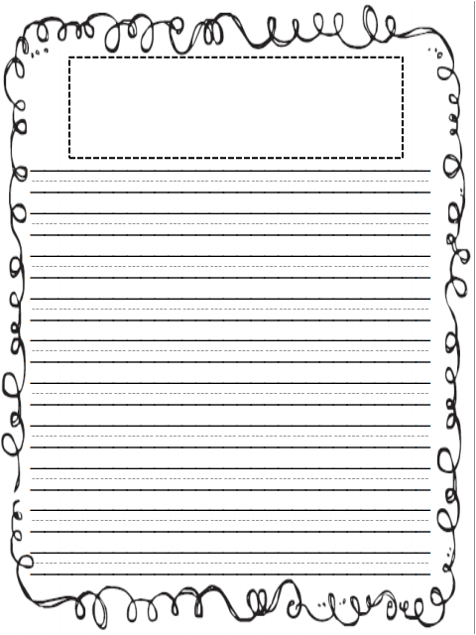
If you had to build a model of a wagon, what material would you use for the handle used to pull the wagon? Explain your choice.

Journal Entry

